September 2021
Press release

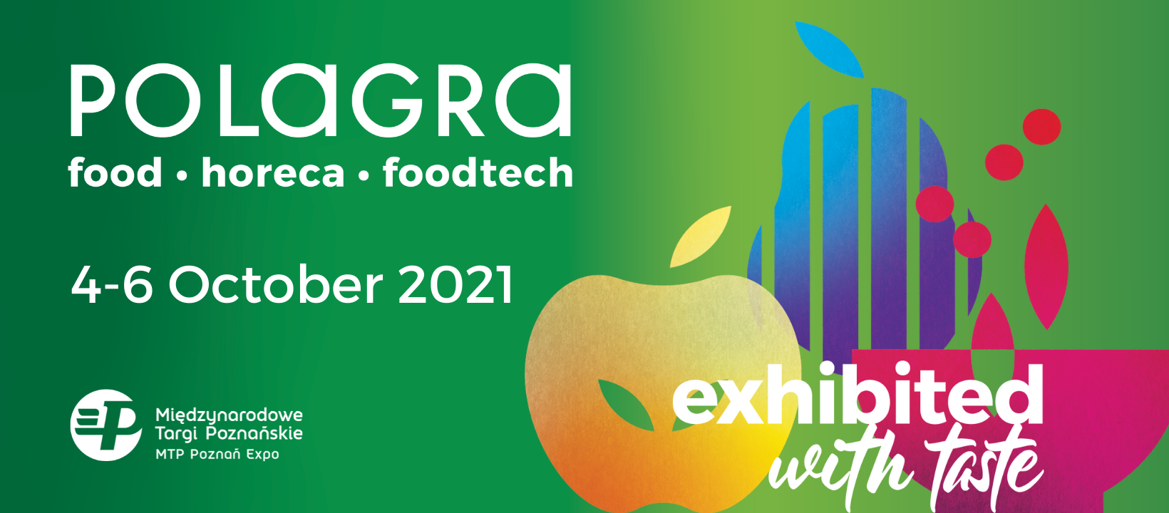

POLAGRA 2021 – exhibited with taste
POLAGRA with its longest business tradition is one of the key-events of food industry and HoReCa in Poland. This year the event will take place on October 4-6 at Poznań International Fair in Poland.
Exhibition full of flavor and inspiration
POLAGRA’s biggest asset is its diversity, and this is not going to change this year. Three parallel salons - FOOD, FOODTECH and HORECA are developed to attract exhibitors presenting food that responds to the dietary preferences of consumers (FOOD salon), new technologies allowing to maintain the highest safety standards in food production (FOODTECH salon), as well as solutions that improve work of restaurants and accommodation facilities (HORECA salon).
Participation in the fair has already been confirmed, among others, by a large group of Polish producers of milk and dairy products or Krajowa Rada Drobiarstwa (National Poultry Council) – the institution bringing together the leading Polish poultry producers as well as meat companies, producers of alcohol products, fruit and vegetable preserves and sweets.
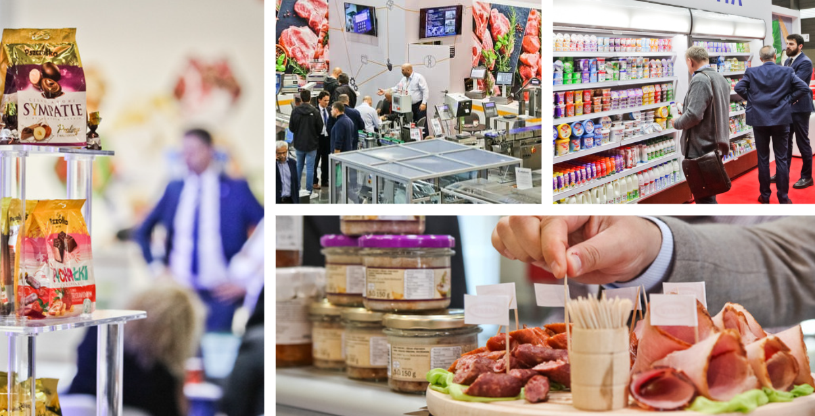
The strong point of the fair will be the exhibition of technologies for the food industry. The POLAGRA will be participated by a large group of companies offering complete machines and lines for the food industry – meat, bakery, dairy and other branches, as well as refrigeration equipment, filtration systems, confectionery and packaging machines.
Formula of the fair
This formula of the fair will combine meetings in the exhibition space at Poznań International Fair with online meetings thorough internet platform based on the operation of artificial intelligence used in associating business partners.
It will significantly expand the scope of the event. Both platforms for talks are not mutually exclusive, but they create a symbiotic solution that both allows for more meetings per company and for more effective development of the network of relations with foreign partners, even in the event of travel restrictions.
Invitations for foreign visitors
The buyers from retail chains and food wholesalers, managers from food plants, restaurateurs and chefs can applicate to receive free invitation HERE. The invitation enables to participate in the fair off site and to take benefits of online platform to make business talks with exhibitors. The representatives from food industry
Professional visitors from abroad can take advantage of a special “Hosted Buyers” programme, too. The project aims to connect Polish producers with foreign buyers willing to commence trade cooperation with a selected group of entrepreneurs. Grupa MTP hosted in recent years over 100 representatives of retail chains from Algeria, Belarus, Belgium, Croatia, Estonia, France, Israel, Italy, Lebanon, Romania, Russia, Saudi Arabia, Ukraine, United Arab Emirates and the United Kingdom.
The Hosted Buyers programme is opened also this year. The details can be achieved by contact with Hosted Buyers Coordinator – Iwona Stefańska (email: iwona.stefanska@grupamtp.pl).
Knowledge exchange platform
The key event will be congress POLAGRA EXPORT MEETING, which is going to be held on October 5, with the support of the Minister of Development and Technology. Main subject of the event will be Polish food promotion in foreign markets increasing competitiveness of domestic products in the EU and other countries. There are plans to present the potential of individual commodity groups, talks on export prospects for the Polish food industry, and barriers to entering selected foreign markets.
POLAGRA will also include the international Meat Sector Conference on the occasion of the General Assembly of UECBV (European Livestock and Meat Trading Union) and YEMCo, organized by the Polish Meat Association, whose main theme is the strategy from farm to table. There are planned also: culinary workshops which will be conducted by outstanding chefs, including the winners of the Polish Culinary Cup, as well as competition and workshops for bakers. There is also planned 7th edition of Hotel Investor Meeting.

POLAGRA has been gathering the whole food and HoReCa sector for years. Long history of the exhibition, prove that it has also been the meeting point, knowledge exchange and industry talks platform. This year’s POLAGA will be created with great taste, keeping the highest safety standards, allowing all its participants to achieve their business goals in the most convenient way.
More information available on: www.polagra.pl/en
Free invitation for visitors:
https://polagra.pl/en/about-event/about-the-fair/?utm_medium=InfoPress&utm_source=Media_Zagranica
Hosted Buyers Programme: https://www.hostedbuyers.eu/en/polagra/

Media, marketing:  Katarzyna Świderska  tel. +48 691 033 850  katarzna.swiderska@grupamtp.pl | Visitors’ service:  Paulina Nowakowska  tel. +48 539 350 021  paulina.nowakowska@grupamtp.pl

