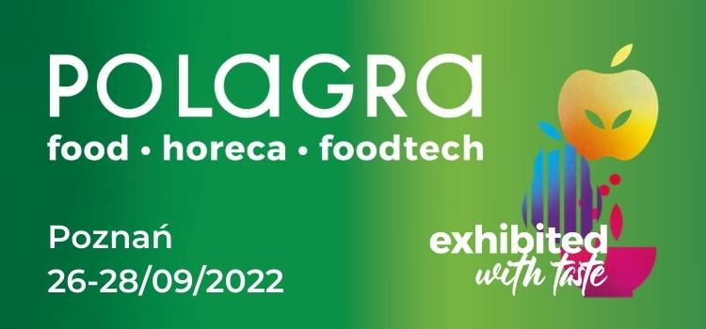
POLAGRA 2022 is approaching fast
The most important event of the food industry and HoReCa sector in Poland will start on the 26th of September in Poznań. It will last three days and, apart from a rich exhibition, it will abound in numerous accompanying events.
As in the recent years, the POLAGRA fair exhibition will consist of the following zones: FOOD, FOODTECH and HORECA. In this way, the entire food industry will meet at the same place and time, i.e. on 26-28 September 2022 on the premises of the Poznań International Fair.
- The POLAGRA trade fair, which took place in October 2021, proved that the food industry and the HoReCa sector need live meetings. Despite a difficult year, the experience of the pandemic, we organised a three-day event that attracted exhibitors and visitors from Poland and abroad, recalls Dariusz Wawrzyniak, Director of the Group of Products, MTP Group.
Apart from the exhibition divided into three zones, a number of panel discussions, debates and training sessions for representatives of various sectors of the broadly defined food and catering industry will be held. They have always been - and will always remain - an integral and very important element of the POLAGRA fair. They enable the exchange of experience and learning about current problems, barriers and opportunities faced by Polish and foreign companies and enterprises in this sector of the economy.
The POLAGRA EXPORT MEETING Congress cannot be missed among these events, which is addressed to, among others, producers, representatives of state institutions supporting Polish food exports, experts from consulting companies, research agencies and representatives of international food distribution companies.
KULINARNY PUCHAR POLSKI [THE POLISH CULINARY CUP], the most prestigious competition for chefs, shall return for this year's edition. In 2021, it was impossible to hold its final due to the pandemic. In September, the winners of preliminaries, i.e. “nominee competitions”, will meet in Poznań during the grand final of the 20th edition of this unique event.
During the POLAGRA fair two other events will also be held: TAROPAK - International Trade Fair of Packaging Technology and Labelling and the Smaki Regionów (Tastes of the Regions) Fair. All three events perfectly complement each other and enable a comprehensive insight into the opportunities and challenges faced by food producers, distributors and the catering industry.
More information:
www.polagra.pl/en

